Local Invasive Plant Species

Japanese Barberry Berberis Thunbergii
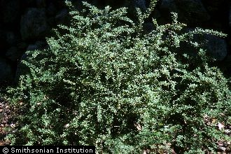
Identification:
- Dense spiny shrub.
- Brown, spiny branches with a single spine at each shoot node.
- Green & blue leaves.
- Matures during late summer and fall and persist through the winter.
- Distinguished by the flowers being produced in umbels. An umbel is an inflorescence which consists of a number of short flower stalks which spread from a common point.
Eradication:

Apply herbicides directly to the plant or use flames to torch.

Oriental Bittersweet Celastrus Orbiculatus
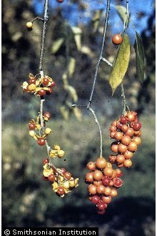

Identification:
- Thin spindly vines.
- Has silver to reddish brown bark.
- Vines wrap around tree trunks.
- Small green flowers that produces red seeds.

Eradication:
Spray with Triclopyr or Glyphosate directly on the plant or plant site annually.

Black Swallow Wort Cynanchum Louiseae
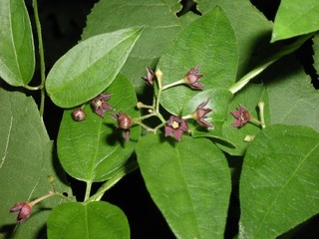
Identification:
- Vine containing oval shaped leaves with a pointy tip.
- Star shaped flowers colored dark purple to black.
Eradication:
Direct spraying of herbicides on the plant after flowering has occurred.

Russian Olive Elaeagnus Angustifolia
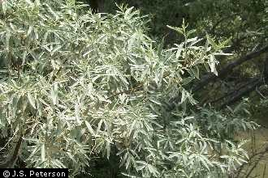
Identification:
- Thorny shrub or small tree with silver to rust colored scales.
- Long smooth Leaves.
- Yellow four-lobed flowers.
Eradication:
Spraying of herbicides directly on the plant or the cutting of the stump.

Autumn Olive Elaeagnus Umbellata
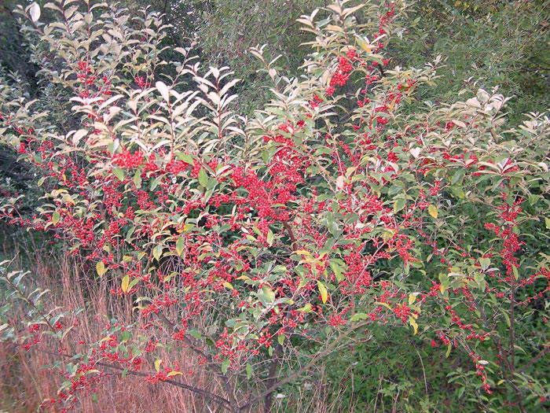

Identification:
- Small shrub with pale yellow flowers and pink to red berries.
Eradication:
Spray herbicides directly on the plant or pull the plant directly out of the ground.

Multi-floral Rose Rosa Multiflora
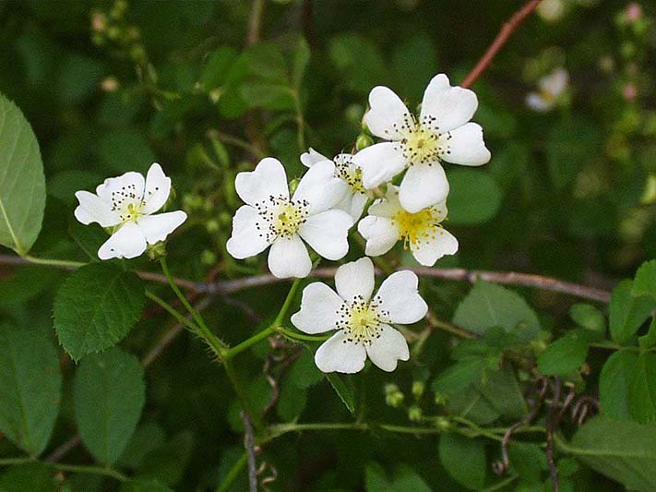

Identification:
- Multi-stemmed shrub, thorns, and pointy tipped leaves.
- Fragrant white to pink flowers.
Eradication:
Spray herbicides directly on the plant or perform regularly scheduled cuttings.

Japanese Honeysuckle Lonicera Japonica
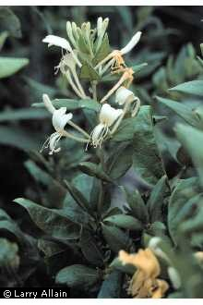
Identification:
- Twining vine with oval leaves.
- White to yellow double tongued flowers.
- Vanilla scented petals.
Eradication:
Cut or burn the plant repeatedly for several weeks.
Garlic Mustard Alliaria Petiolata
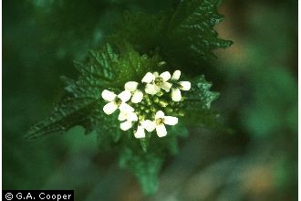
Identification:
- Tall green plant. When the leaves are crushed it smells of garlic.
- Round shaped leaves.
- White cross shaped flowers.
Eradication:
Simply pull, cut or burn the plant.

Nepalese Browntop (aka Japanese Stilt Grass) Microstegium Vimineum
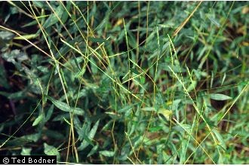
Identification:
- Tall thin plant with long leaves containing a silver stripe down the center.
Eradication:
Spray herbicides directly on the plant either before or after emersion.
Japanese Knotweed Fallopia Japonica
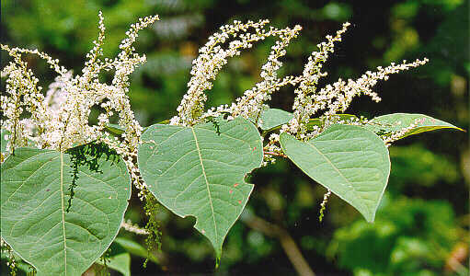
Identification:
- Tall hollow stems similar to bamboo.
- Large oval leaves.
- Small cream to white colored flowers.
Eradication:
Cut the plant down to its roots and apply herbicides to the stumps.

